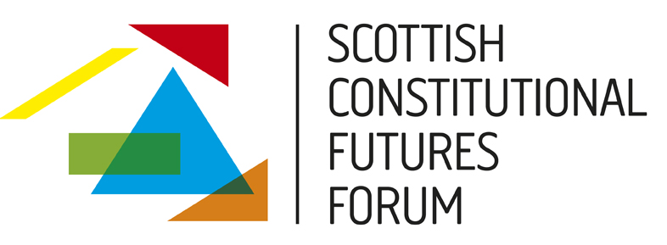

After the Referendum: A Constitution for an Independent Scotland

13 November 2013

Court/Senate Suite, Collins Building, University of Strathclyde

9.15 am – 5 pm

This is the first of two workshops exploring the implications of a referendum for Scotland’s constitution. This workshop focuses on the constitutional implications of a yes vote; the second, to be held at the University of Glasgow on 26 November 2013, will discuss what constitutional changes might nevertheless be desirable in the event of a no vote.

The widely shared assumption – endorsed by the Scottish Government – is that an independent Scotland would join the overwhelming majority of nations in adopting a written constitution. In this workshop we will explore a range of issues raised by the prospect of a written Scottish constitution, including: the process for adopting a constitution and interim constitutional arrangements; the content of a written constitution, covering both substantive values and institutional questions; and the legal status of a written constitution, exploring models of entrenchment, interpretation and amendment, as well as the relationship of the constitution to other regional and global legal orders.

Programme

9 am – 9.15 am: Registration and coffee

9.15 am – 9.20 am: Welcome

9.20 am – 10.50 am: Session 1: The when and the how of constitution-making

Chair: Dr Chris McCorkindale, University of Strathclyde

Paper 1 – Managing the Constitutional Transition, Colin McKay, Scottish Government

Paper 2 – Comparative Lessons for Effective Constitution-Making, Dr Elliot Bulmer, International Institute for Democracy and Electoral Assistance

Paper 3 – Citizen Participation in Constitution-Making, Oliver Escobar, University of Edinburgh

10.50 am – 11.10 am: Coffee

11.10 am – 12.40 pm: Session 2: Constitutional values for an independent Scotland

Chair: Nick Barber, University of Oxford

Paper 1 – In Praise of Short Constitutions, Andrew Tickell, University of Oxford

Paper 2 – Protecting Socio-Economic Rights, Professor Keith Ewing, King’s College London

Paper 3 – The Constitution and Public Goods, Professor Aileen McHarg, University of Strathclyde

12.40 pm – 1.45 pm: Lunch

1.45 pm – 3.15 pm: Session 3: Constitutional institutions in an independent Scotland

Chair: Professor Stephen Tierney, University of Edinburgh

Paper 1 – The Role of the Scottish Parliament in a Devolved or Independent Scotland, Professor Paul Cairney, University of Stirling

Paper 2 – The Executive in the Constitution, Professor Alan Page, University of Dundee

Paper 3 – Local (and Regional?) Government, Professor Chris Himsworth, University of Edinburgh

3.15 pm – 3.30 pm: Coffee

3.30 pm – 5 pm: Session 4: The constitution as higher law

Chair: Jean Urquhart MSP

Paper 1 – Models of Constitutional Enforcement, Christine O’Neill, Brodies

Paper 2 – The Living Constitution, Dr Elisenda Casenas Adam, University of Edinburgh

Paper 3 – The Constitution and other Legal Orders, Professor Neil Walker, University of Edinburgh

